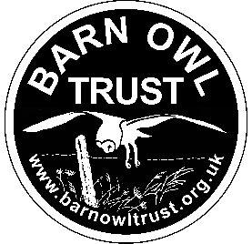
Barn Owl Trust Job Application Form
Assistant Conservation Officer
Please complete this form and email it to kaye@barnowltrust.org.uk
1) HOW DID YOU HEAR ABOUT THIS VACANCY?

2) YOUR PERSONAL DETAILS

Any preferred title (e.g., Mrs):  Surname:  First names:  Address: |  |  |  | Work telephone:  May we ring you at work? Yes/No  Home telephone:  Mobile telephone:  E-mail address:
3) PRESENT EMPLOYMENT (or if now unemployed, details of last employment):
Name and address of employer: |  |  |  |  | Job title:  Present salary:  From (month/year):  To (month/year):  May we contact your current/last employer? Yes / No
Please give a brief description of your position, your responsibilities, and key achievements:
(Continue on a separate sheet if necessary)

Reason for leaving:

What notice period do you have to give (if applicable)?
4) EDUCATION AND QUALIFICATIONS - Please give details of your education and the qualifications you have obtained:

Schools/Colleges/University etc: |  | From:  (month/year) |  | To:  (month/year) |  |  | Qualifications obtained and grades
Details of any further qualifications obtained, or relevant courses attended, including dates:

Driving
Do you hold a full driving licence? Yes/No
Do you have any endorsements on your licence? (Please provide details) Yes/No
Have you received any off-road driver training? Yes/No
Do you have a licence/training to tow and reverse a trailer? Yes/No

5) PHYSICAL ABILITY
Please be aware: Interviews include a manual handling exercise involving lifting, moving, and erecting a 24 kg ladder
Are you physically capable of safely lifting and erecting a 3-section ladder weighing 24 kg? Yes/No
Are you happy to work at a computer screen for the majority of a working day? Yes/No

6) EMPLOYMENT HISTORY - Please give details of your previous employment over the past ten years (starting from the most recent):

Name of Employer | From:  (month/year) |  | To:  (month/year) |  |  | Salary: |  | Job title, description of the post and reason for leaving:

7) CONSERVATION EXPERIENCE (professional and/or voluntary) and RELEVANT SKILLS:
(Please provide brief outline)

8) ADDITIONAL RELEVANT INFORMATION - Please set out any additional information, including other relevant experience, you think will demonstrate your ability to succeed in this role and how you meet the person specification. This is the part of the application form where you can bring to our attention any qualities or experience you feel we should be aware of. We are particularly interested in knowing more about your personal interests (hobbies/activities). Please continue on a separate sheet if necessary.

9) REFERENCES - Employment related
Please give the names and contact details of two people to whom we may apply for a reference (one of these should be your current/most recent employer):
Reference 1 | Reference 2
10) May we approach the above without further reference to you prior to an interview? Yes/No

11) Are you available on the interview date? Yes/No

12) Have you previously applied for a position with the Barn Owl Trust? Yes/No
If yes, please give details:

13) Have you ever had any criminal convictions? Yes/No
If yes, please give details:

Equality, Diversity and Inclusivity
We consider applicants for all positions without regard to age, sex, sexual orientation, pregnancy or maternity, race, ethnicity, nationality, religion or belief, gender identity expression or reassignment, relationship status, martial status and civil partnership, caring responsibilities, trade union activities or political beliefs or any other grounds.
Disability is considered in relation to the inescapable physical demands of the post and the ability to work safely.
14) If invited to interview, are there any adjustments that are required? Yes/No
If yes, please give details:

DECLARATION – please read this carefully before signing the application

☐ I agree that any offer of employment is subject to satisfactory references and checks (if required) and a probationary period.

☐ I confirm that the information provided in this application form and all the documents required, are complete and correct and that any untrue or misleading information will give my employer the right to terminate any employment contract offered.

☐ If I am appointed, I agree that this form will form part of my Contract of Employment and will be held on my personal records.

Signed:
(A typed signature is acceptable)

Print Name:

Date:

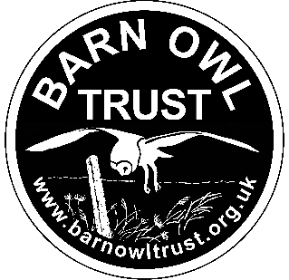

Please email your completed form to kaye@barnowltrust.org.uk

